Dev Test evidence for DataExporter
Run the application in Visual Studio. This will display a port number for the client to connect to the host server.
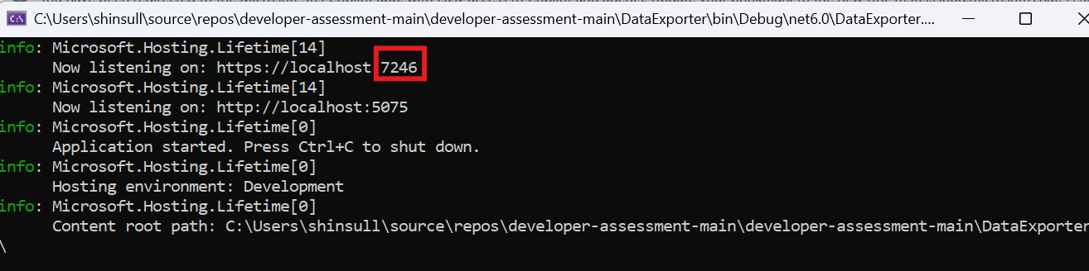
Using Powershell ‘Invoke-RestMethod’ to test the API
Test case 1 - GetPolicies (GET all)
Return all existing policies
Invoke-RestMethod -Uri "https://localhost:7246/policies" -Method GET
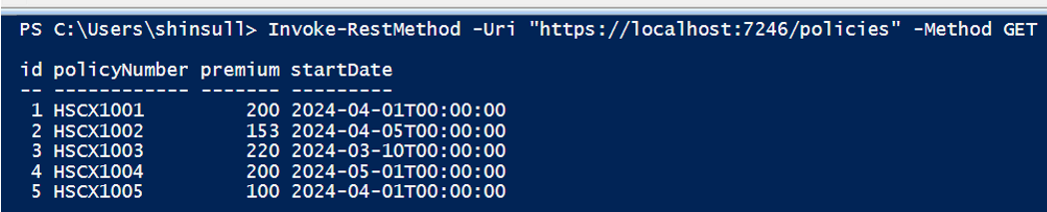
To get Json format
Invoke-RestMethod "https://localhost:7246/policies" | ConvertTo-Json -Depth 10
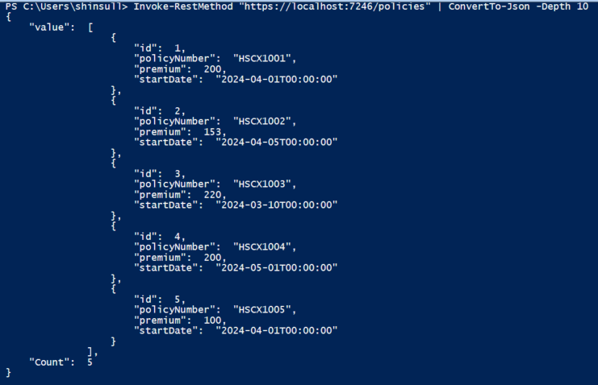

Test case 2 - GetPolicy (GET by id)
Test case 2.1 Policy Id exists, return one existing policy
Invoke-RestMethod -Uri "https://localhost:7246/policies/1" -Method GET
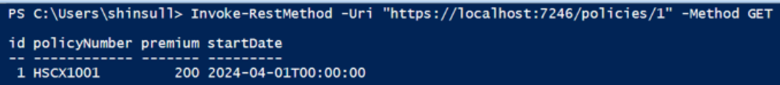
To get Json format
Invoke-RestMethod -Uri "https://localhost:7246/policies/1" -Method GET | ConvertTo-Json -Depth 10
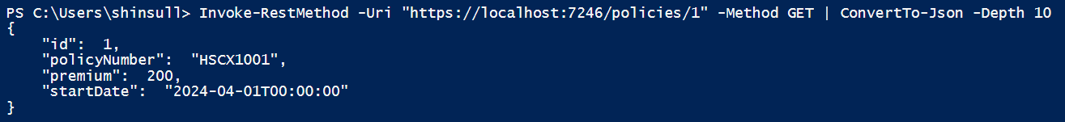
Test case 2.2 Policy Id not exists, for example id=10, return ‘Not Found’ (404)
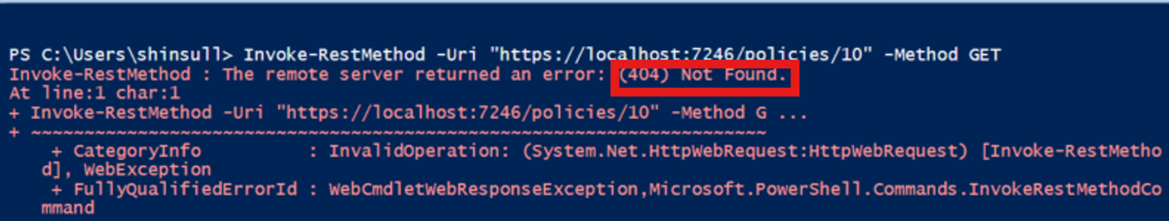

Test case 3 PostPolicies (POST new policy)
Create a new policy based on the data of the DTO it receives in the body of the call
Invoke-RestMethod -Uri "https://localhost: 7246/policies" `
-Method POST `
-ContentType "application/json" `
-Body '{
"policyNumber": "HSCX2001",
"premium": 120.50,
"startDate": "2024-04-01T00:00:00Z"
}'
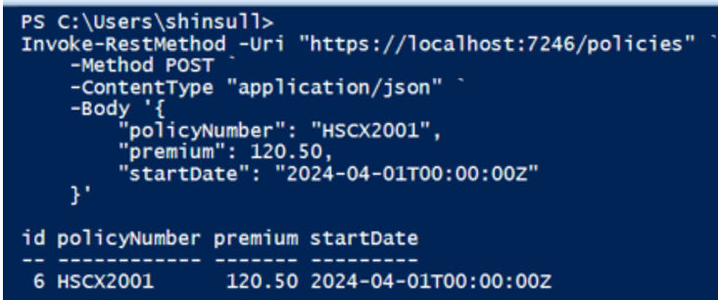

Test case 4 - the Export
The call receives two parameters from the query string, the startDate and the endDate. Retrieve all policies that have a start date between those two dates, and all of their notes.
Invoke-RestMethod -Uri "https://localhost:7246/policies/export?startDate=2024-04-01&endDate=2024-05-01" -Method POST
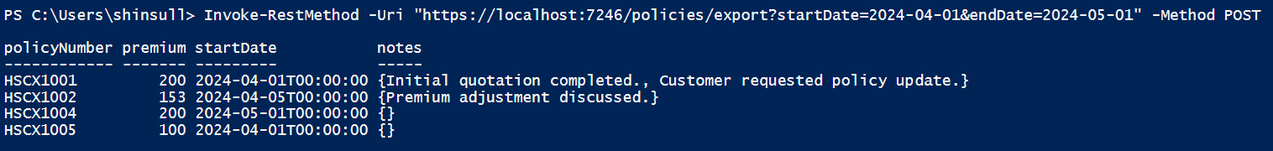
Invoke-RestMethod -Uri "https://localhost:7246/policies/export?startDate=2024-04-01&endDate=2024-05-01" -Method POST |
ConvertTo-Json -Depth 10
